**Australian Islamic College 2019**

**ATAR Chemistry Units 3 and 4**

**Task 6 (Weighting: 3%)**

**Redox and Electrochemistry Test**

Test Time: 50 minutes

Please do not turn this page until instructed to do so.

|  |  |
| --- | --- |
| **First Name** | **Surname** |
|  |  |

|  |
| --- |
| **Teacher** |
|  |

|  |  |
| --- | --- |
| **Mark / 52** | **Percentage** |
|  |  |

Equipment allowed: Pens, pencils, erasers, whiteout, correction tape, rulers and non-programmable calculators permitted by the Schools Curriculum and Standards Authority.

**Special conditions**:

2 marks will be deducted for failing to write your full name on this test paper.

**Teacher help**: Your teacher can only help you during your test in one situation.

If you believe there is a mistake in a question show your teacher and your teacher will tell you whether or not there is a mistake in the question and if appropriate, how to fix that mistake.

**Spelling of Science words** must be correct. Science words with more than one letter wrong (wrong letter and/or wrong place) will be marked wrong.

**Equations** must be written balanced and with correct state symbols or they will be marked wrong.

Questions must be answered in this booklet.

Total marks: 52

**PART ONE: MULTIPLE CHOICE QUESTIONS (10 MARKS)**

1. Which one of the following species listed below contains sulfur with the lowest oxidation state?

(a) SO3

(b) SO2

(c) (NH4)2S

(d) H2SO4

2. In which one of the following processes is the oxidation number of chlorine being increased by 2?

1. PCℓ3 + Cℓ2 → PCℓ5
2. Cℓ2 + H2O → Cℓ– + HCℓO + H+
3. 2Cℓ– + 2 e– → Cℓ2
4. CℓO3– + H2O2 → CℓO4– + H2O

3. Which one of the following substances is capable of oxidising copper metal?

(a) Zn

(b) Br2

(c) CrCℓ3

(d) Au

4. Which one of the following pairs of chemicals will undergo a spontaneous redox reaction?

(a) solid iodine and water

(b) solid lead and liquid bromine

(c) lead nitrate solution and potassium iodide solution.

(d) solid copper and a 1.0 mol L-1 solution of hydrochloric acid.

5. The following half-reactions occur in a zinc-carbon cell during discharge.

Anode Zn(s) 🡪 Zn2+(aq) + 2e-

Cathode 2MnO2(s) + 2NH4+(aq) + 2e- 🡪 Mn2O3(s) + 2NH3(aq) + H2O(l)

What is the oxidising agent in a zinc-carbon cell?

1. Zn.
2. Mn.
3. MnO2.
4. NH4+.

**The following diagram relates to questions 6, 7 and 8.**

The following galvanic cell was set up. Platinum (Pt) is an inert electrode.

**V**

Pt

Sn

1.0 mol L-1  Fe2+/Fe3+

1.0 mol L-1  Sn2+

Salt Bridge

(K+ , NO3–)

6. When the circuit is connected, which one of the following concentrations will decrease?

(a) [Fe3+]

(b) [Fe2+]

(c) [Sn2+]

(d) [K+]

7. When the circuit is connected, which one of the following will be the changes of masses of the electrodes?

|  |  |  |
| --- | --- | --- |
|  | **Mass of tin electrode** | **Mass of platinum electrode** |
| (a) | increases | decreases |
| (b) | increases | no change |
| (c) | decreases | no change |
| (d) | no change | increases |

8. Which one of the following would be the expected reading on the voltmeter?

(a) 0.63 V

(b) 0.90 V

(c) 1.68 V

(d) 0.30 V

**Question 9 and 10 relate to the following information**

Most car batteries consist of six cells. The cell reactions involve lead, lead(IV) oxide and lead sulfate. Each cell produces just over 2 volts when fully charged. The car battery is a secondary battery.

The following reactions occur in a lead–acid battery as it discharges (produces electricity).

Anodes Pb(s) + SO42−(aq) → PbSO4(s) + 2e−

Cathodes PbO2(s) + SO42−(aq) + 4H+(aq) + 2e− → PbSO4(s) + 2H2O(ℓ)

9. The car battery is described as secondary because

1. it requires two separate reactions.
2. the cells can be recharged.
3. it contains more than one cell.
4. it requires the reactants to be supplied to the cell during operation.

10. Which one of the following is the overall equation for the discharging of the cell?

(a) Pb(s) + PbO2(s) + 2SO42−(aq) → 2PbSO4(s) + 2H2O(ℓ)

(b) Pb(s) + PbO2(s) + 2SO42−(aq) + 4H+(aq) → PbSO4(s) + 2H2O(ℓ)

(c) Pb(s) + PbO2(s) + H2SO4(aq) → 2PbSO4(s) + 2H2O(ℓ)

(d) Pb(s) + PbO2(s) + 2SO42−(aq) + 4H+(aq) → 2PbSO4(s) + 2H2O(ℓ)

**END OF MULTIPLE CHOICE SECTION**

**PART TWO: SHORT ANSWER QUESTIONS (19 marks)**

This section has **2** questions. Answer both questions. Write your answers in the spaces provided.

**Question 11 (4 marks)**

The two initial reactions involved in the wet corrosion of iron are shown below. Both of these reactions are reversible.

Oxidation (anode) reaction: Fe(s) → Fe2+(aq) + 2e–

Reduction (cathode) reaction: O2(g) + 2H2O(ℓ) + 4e– → 4OH–(aq)

(a) Combine these two equations to write a redox reaction for the process. (1 mark)

|  |
| --- |
|  |

(b) Use your knowledge of chemical equilibrium to predict whether iron will corrode more quickly in water that is slightly acidic or water that is slightly basic. Justify your reasoning.

(3 marks)

|  |
| --- |
|  |
|  |
|  |
|  |

**Question 12 (15 marks)**

Below is a representation of an electrochemical cell.

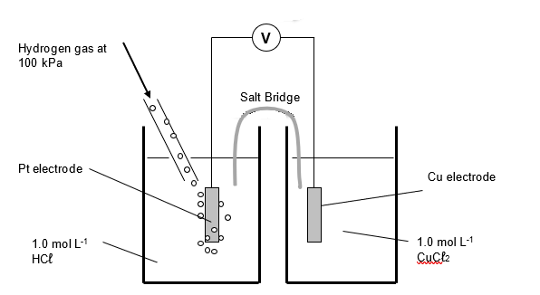

(a) Give the half-equation for the reactions occurring at the anode and cathode and write an overall redox equation for the reaction occurring in the cell. (3 marks)

|  |
| --- |
| Anode half-equation: |
| Cathode half-equation: |
| Overall equation: |

(b) On the diagram:

1. draw an arrow that shows the direction of electron flow through the external circuit. (1 mark)
2. label the electrode which is the ANODE. (1 mark)
3. label the electrode which is POSITIVE (1 mark)
4. draw an arrow on the salt bridge to show the direction of the migration of POSITIVE IONS. (1 mark)

(c) Standard electrode potentials are measured at standard conditions as shown in the diagram in (a). According to theory, “**increasing reactant concentration will increase the cell potential”.** Based on this statement, predict the effect on the value of the cell potential when each of the following changes were made to the cell. Explain your reasoning. (Equations are not required in your explanations). **(8 marks)**

|  |  |  |
| --- | --- | --- |
| **Change** | **Effect on cell potential**  **(Increase, decrease or no change)** | **Reasoning** |
| The pressure of hydrogen gas is increased to 200 kPa |  |  |
| A larger copper electrode is used |  |  |
| A few drops of silver nitrate solution are added to the copper(II) chloride solution |  |  |
| The platinum electrode is replaced by a (inert) graphite electrode. |  |  |

**END OF PART 2**

**PART THREE: COMPREHENSION TASK EVALUATION (23 MARKS)**

Answer each of the following questions in the space provided.

**Question 13**  
The following diagram represents some of the features of a alkali fuel cell, such as those used on the Apollo missions to the moon. The electrode is a hot solution of KOH soaking in an asbestos cloth. The electrodes are a porous nickel-based material. The electrodes are coated in platinum.

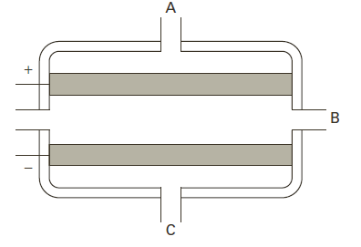

**D**

(a) At which place in the fuel cell (A,B,C or D) would hydrogen gas enter ? (**1 mark**)

|  |
| --- |
|  |

(b) At which point (A,B,C or D) would oxygen gas enter the fuel cell? (**1 mark**)

|  |
| --- |
|  |

(c) Is D the anode or the cathode? (**1 mark**)

|  |
| --- |
|  |

(d) What is the purpose of the platinum that coats the electrodes? (**1 mark**)

|  |
| --- |
|  |

(e) Assuming that an alkaline electrolyte is used in the hydrogen/oxygen fuel cell, write the half reactions and the overall balanced chemical reaction for the fuel cell. (**3 marks**)

|  |
| --- |
| Anode half-equation: |
| Cathode half-equation: |
| Overall equation: |

**Question 14**

Balance the following unbalanced redox reaction occurring in acidic medium using the half-reaction method. Write an oxidation half-equation, a reduction half-equation and an overall balanced equation. State symbols are not required.

Sb2S3 + NO3- 🡪 Sb2O5 + HSO4 - + NO (6 marks)

|  |
| --- |
| **Oxidation half-equation:** |
| **Reduction half-equation:** |
| **Overall equation:** |

**Question 15**

State and explain two (2) advantages and two (2) disadvantages of fuel cells over conventional galvanic cells. (**4 marks**)

Advantage 1:

Advantage 2:

Disadvantage 1:

Disadvantage 2:

**Question 16**

Refer to the diagram below to answer the questions. Note that ‘chlorine water’ is Cl2(aq).

**[6 Marks]**

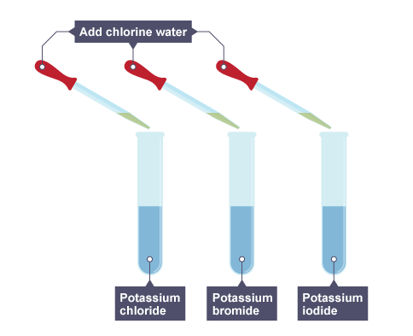

1. Which of the test tubes will undergo a redox chemical reaction? (1 mark for both)

____________________________________________________________

1. Write down the balanced ionic equations for all the reactions. (2 marks including states)
2. Write observation for all three test tubes (3 marks)

____________________________________________________________________________________________________________________________________________________________________________________________________________________________________________________________________________________________

**Blank Page for Student Use**

**END OF TEST**